# CS 255 System Design Document Template

*This system design document provides a detailed overview of the DriverPass system, including its UML diagrams and technical requirements. The proposed design incorporates both object-oriented and process-oriented approaches to ensure a comprehensive and efficient system that meets the client's needs.*

## UML Diagrams

### UML Use Case Diagram

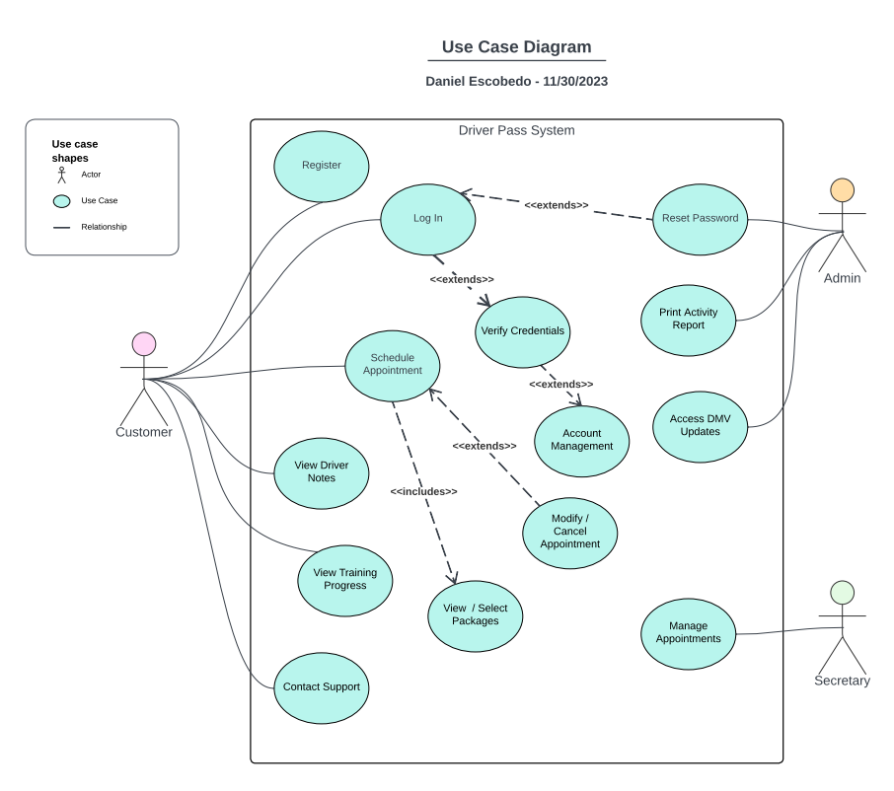

### UML Activity Diagrams

*UML Activity Diagram 1: Login*

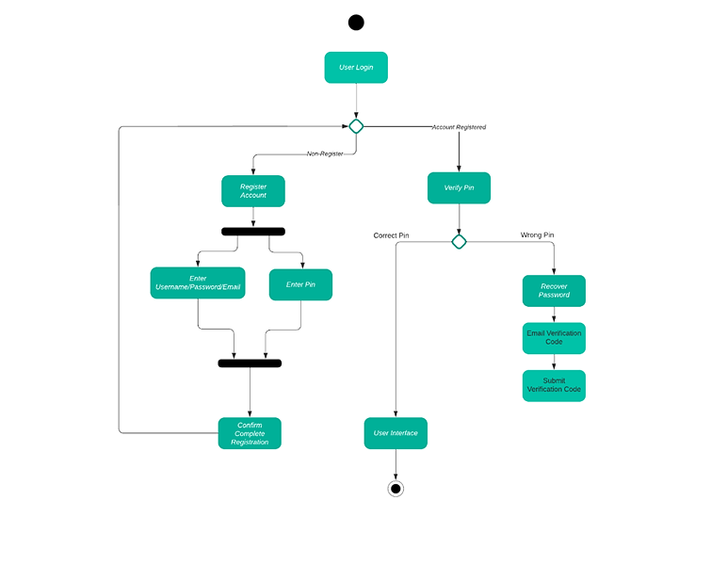

*The UML activity diagram for user login and registration depicts a two-pronged process. The main path starts with the user entering their login credentials. The system then verifies the information against existing user accounts. If the credentials are valid, the user is granted access to the system. Conversely, if the credentials are invalid or not found, the process forks into a secondary path where the user is presented with a registration form. Upon filling out the form and submitting it, the system validates the information and creates a new user account.*

*UML Activity Diagram 2: Package Selection*

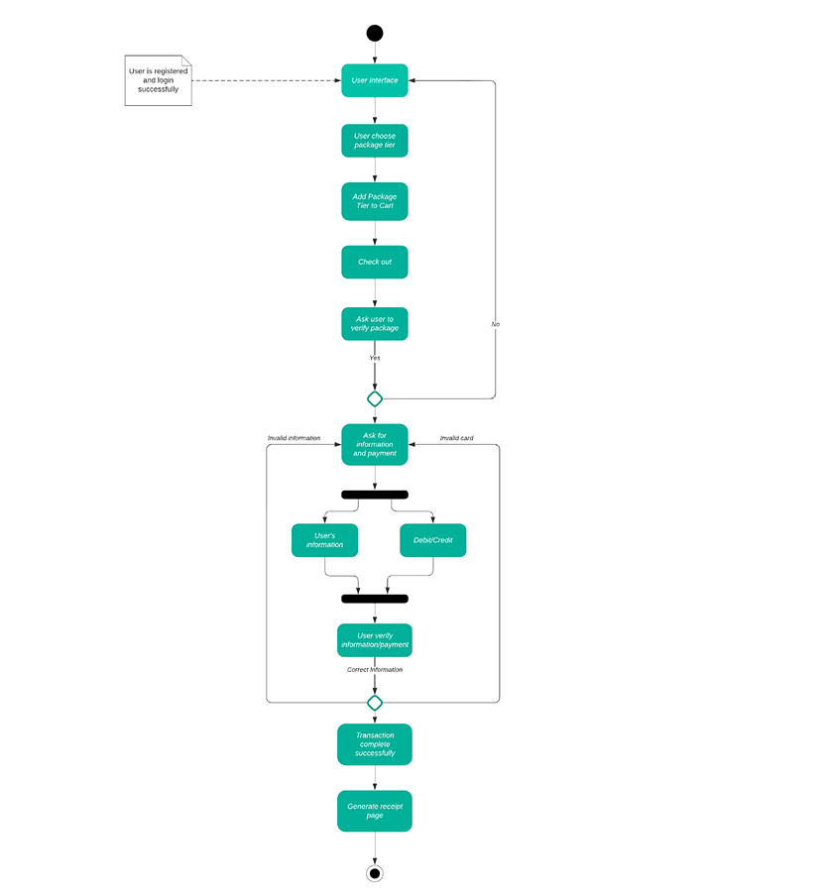

*The user browses available packages and selects one. They then enter their personal and payment information. If valid, the system creates a receipt, processes the payment, and provides access to the selected package.*

### UML Sequence Diagram

*The UML sequence diagram for scheduling appointments depicts the interactive dialogue between the secretary, customer, and the system. The customer initiates the process by submitting an appointment request through a designated channel, specifying their desired service and preferred date/time range. The secretary receives the request and retrieves the customer's information. They then check the availability of the service provider for the requested time range and offer available options to the customer. The customer reviews the offered options and confirms their selection. The system updates the appointment schedule and sends notifications to both the secretary and the customer, confirming the appointment details and providing any necessary reminders. This back-and-forth communication continues until a mutually agreeable time slot is found and the appointment is finalized.*

### UML Class Diagram

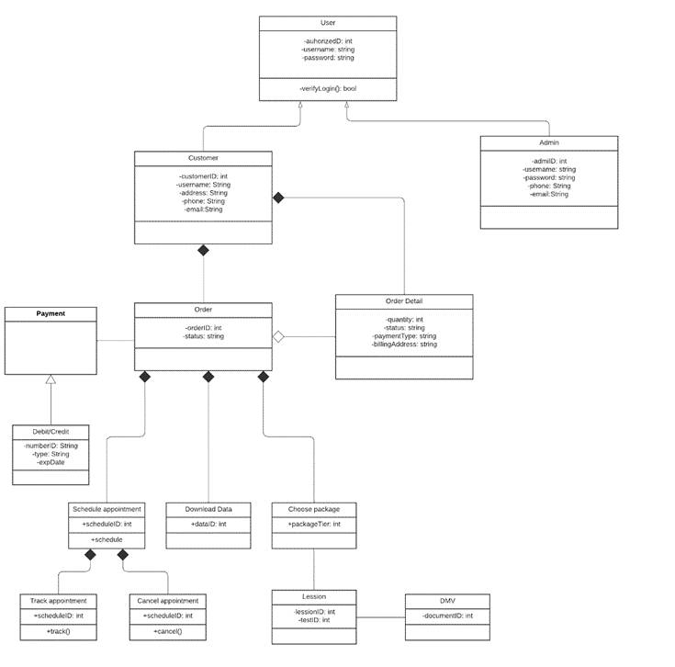

## Technical Requirements

*The DriverPass system requires a robust infrastructure to accommodate future growth and high-volume transactions. Secure cloud computing will host the system, ensuring high availability and scalability. Data security and encryption protect sensitive information, while a disaster recovery plan ensures system continuity. Performance, usability, and security are top priorities to guarantee a reliable and user-friendly system for businesses and drivers.*

***Hardware:***

* *Servers with sufficient processing power and storage capacity.*
* *Network infrastructure with high bandwidth and low latency.*
* *Mobile devices (smartphones) for drivers and passengers.*

***Software:***

* *Operating system: A stable and secure operating system for the servers.*
* *Database management system: A robust database management system to store and manage driver information and transaction data.*
* *Web application: A user-friendly web application for businesses to register, manage drivers, and verify their information.*
* *Mobile application: A mobile application for drivers to register, upload documents, and receive verification requests.*
* *API integration: Integration with external APIs for services like document verification and identity verification.*

***Tools:***

* *Case management tool: A tool to track and manage support tickets and driver verification requests.*
* *Reporting tool: A tool to generate reports on driver activity, verification history, and other system metrics.*
* *Version control system: A system to manage and track changes to the system code and documentation.*
* *Secure coding practices for data*